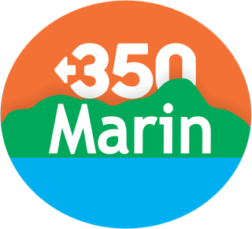 Summer 2025 College Internship: Climate Action Specialists
We are seeking self-starters with a passion for addressing the climate crisis, with strong organizational and communication skills. Interns will work closely with the 350Marin Steering Committee and the community of Marin County to further civic engagement via our committees, campaigns, events and actions.
Under the supervision of a founding member of 350Marin, interns will collaborate with local environmental and community leaders across the nonprofit, public, and private sectors. The interns will gain experience researching, evaluating and implementing climate actions and policies, gaining invaluable knowledge of how grassroots climate activism works in the process. Anticipated activities:
- Work closely with local government committees/commissions, and evaluate initiatives and policies to further the implementation of Climate Action Plans, with particular attention to 3 cities: Novato, Fairfax, and San Anselmo.
- Support campaigns and initiatives focused on: 1) advocacy for climate leadership in local elections, 2) the electrification of homes, buildings and schools; 3) equity issues in climate initiatives, and 4) additional related topics.
- Develop materials for community outreach to promote individual, community and municipal climate action. This will include content development for websites, flyers and postcards for public distribution, posters/signs for display, presentation materials for community meetings and events, and the use of social media for engagement.
- Attend meetings of the 350Marin Steering Committee, and other meetings, locally and regionally
The internship will culminate in writing a research paper and creating a final oral Zoom presentation of work accomplished as well as submitting a final paper reflecting on the experience of the internship.
This internship is designed as a learning opportunity to support the local climate movement. We encourage all interested applicants to apply, even if they do not have experience in every area listed below. The ideal candidate may have
- An educational background in environmental science, policy, engineering, sustainable management, planning or the social sciences; relevant volunteer and prior internship experience will be considered.
- An interest in climate change mitigation and adaptation via programs such as electrification of the built environment, clean transportation and mobility options, microgrids and resiliency centers, carbon sequestration, etc.
- Community outreach and communications experience.
- Experience with office software for document development and management, and meeting management.
- Experience in information/data collection and basic analysis of research.
- Strong organizational, verbal, and written skills; ability to work in person and remotely.
We value enthusiasm and a commitment to learning, so if you’re passionate about climate action, we encourage you to apply!
This position will require a minimum of 10-15 hours per week with an 8-week commitment. A small stipend is offered and 350Marin is committed to supporting the search for additional funding if needed.
Contact info@marin350.org or apply at: https://350marin.org/internship-application, open until filled.
About Us: Inspired by the global 350.org climate movement, 350Marin is a local group of 350BayArea.org. For 12 years, 350Marin has brought together concerned grassroots activists working to avert climate chaos. We take actions on the belief that climate science and social justice demand the swiftest possible action to reduce carbon emissions, prioritizing those most impacted. Our goal is to elevate the voice of the people to influence the public and to encourage adoption of local and regional policies that can lead to a safer climate. 350Marin strongly encourages applications from women, LGBTQIA+ people, people of color, indigenous people, disabled people, and other underrepresented communities. 2.24.25

